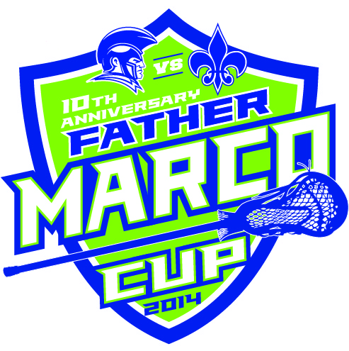2014 Father Marco Event Schedule
8:00am Set Up
Grounds/Tents and Food service area
9:30am Unofficial Check in begins
10:00 Main check in tent opens BBQ lunch / Tailgate opens Pretzel and Water sales begin
11:00am Freshman Game Half Time Referee LAX Demonstration 50/50 Lax Ball Toss
1:00pm Junior Varsity Game Half Time Referee LAX Demonstration 50/50 Lax Ball Toss
2:30pm (end of JV game) Intercom system-Interviews with Gait/DeBeer and beneficiaries
3:00pm Varsity Game Half Time Referee LAX Demonstration 50/50 Lax Ball Toss Prep Cast Broadcast – Interviews with Gait/DeBeer and beneficiaries
4:00pm (between 3/4th period) Matthews Dickey and Loyola check presentations
4:30pm (end of Varsity game) Cystic Fibrosis check presentation Presentation of Father Marco Cup BBQ Lunch / Tailgate closes
5:30pm Mass - SLUH Chapel SLUH/DeSmet (all invited)
6-6:30pm Final Cleanup
Key Contacts: SLUH John Thomas 314 605-7220 DeSmet Mary Mosqueda 314 -283-1468 / Bridget Cafazza 314-960-7431

