Father Marco Lacrosse Cup
Parent / Family Pre-Order T-Shirt Form
All proceeds benefiting:
Cystic Fibrosis Foundation – Gateway Chapter
Loyola Academy of St. Louis – Lacrosse Program
Mathews-Dickey Boy’s and Girl’s Club – Lacrosse Program
2014 is the 10th Anniversary of the Father Marco Cup !!! Show your support by
purchasing a Fr. Marco Cup T-Shirt supporting these Great Organizations !

. VS 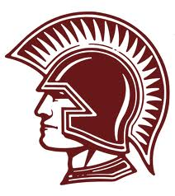

Name:_____________________________
2014 Shirts are Sport-Tek Competitor T’s, Shirts are 100% polyester moisture wicking, with a roomy, athletic cut…Shirt sizes below indicate chest measurements… Shirts will again be green with a new logo ! Pre-ordered shirts are $12.00 / Game Day price is $15.00…
Shirt Size & Qty:
S(35-37)____ M(38-40)____ L(41-43)____ XL(44-46)_____ XXL(47-49)_____
Total Shirt Qty:_____ @ $12.00 = __________
Cash or Check- Checks made out to SLUH Lacrosse
Return orders to John Thomas, 1224 Glenvista Place, Glendale, Mo 63122 jthomas22@charter.net 314 605-7220 no later than Monday March 24, 2014.

