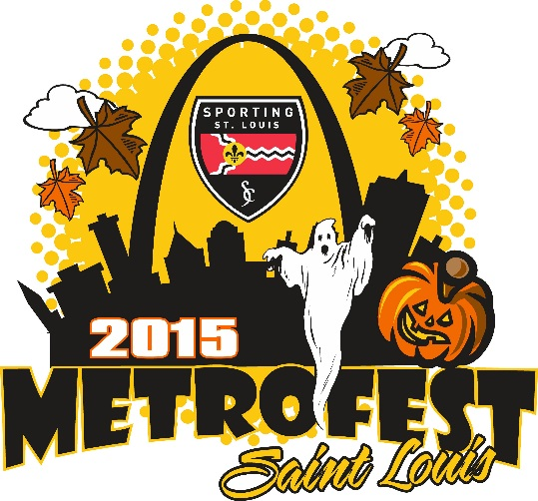
October 16-18, 2015
In addition to high-quality on-field competition, the ACPV will be co-hosting a Pumpkin-Carving Contest with our friends at Thies Farms. In keeping with our mission to help players become the best citizens they can be, this opportunity to exhibit teamwork, discipline, and communication skills in a fun, non-pressured environment we believe will add to the enjoyment of our Sporting STL MetroFest!
The best-carved pumpkin will be awarded their own Sporting STL MetroFest Trophy! Bring your favorite carving tools, we will provide the pumpkins and candles to each team entered in the tournament. We will award two trophies for the best carved pumpkin, 8v8 and 11v11.
Reserve your team pumpkin by sending an email to robyn.gross@acportavia.com, no later than October 8th. You can pick up your pumpkin at the main tournament tent, near the concession stand on Friday or Saturday, and return to the tent by 4pm Saturday
Join the fun; we will have a "PUMPKIN GLOW" on Saturday night at the fields!
Past Winners
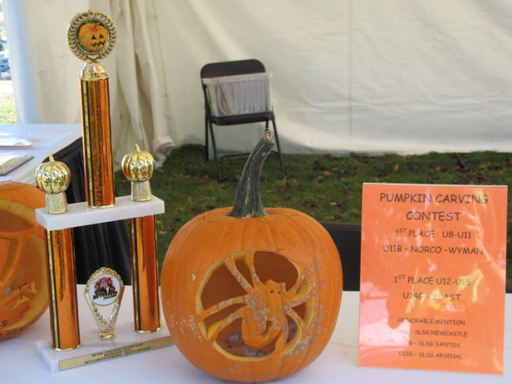 | 